## ****The Online Student Result Management System****

****October 17, 2022****

****Introduction;****

****As universities embrace information and communication technologies, they employ it in transforming their record keeping and information management operations. Particularly, students result management system (RMS) is one of the key information systems that readily attracts the attention of most universities . While the universities in the developed countries already have well established students result management systems, their counterparts in the developing countries are having series of adhoc and standalone result management systems that provide only some basic elements of students result management system. Equally, majority of the students RMS do not have web interfaces and others do not integrate well with the other university-wide information system. The major challenge is that the universities outsource the development of such RMS without proper understanding of the essential functionalities and compatibility issues the RMS should afford to the university.****

1. ****Project Description****

The thrust of this paper is the development of Student Result Management System (SRMS) tailored to organize and manage students’ result and transcript in the various departments in the University

The Administrator user is the user who is in charge of managing the data in the system such as the subject list and the student list. admin users can manage the student result and marks and the Student Users can only view their results and they can only access their results by providing or submitting their Student ID number as their system credentials. The student result displays the student marks per subject and the average from the sum of their marks.

1. Project Scope

* **Login and Logout**
* **Dashboard**
  + Displays the Summary of the lists
* **Class Management**
  + Add New Class
  + List All Classes
  + Update Class Details
  + Delete Class
* **Subjects Management**
  + Add New Subject
  + List All Subjects
  + Update Subject Details
  + Delete Subject
* **Student Management**
  + Add New Student
  + List All Students
  + View Student Details
  + Update Student Details
  + Delete Student
* **Student Result Management**
  + Add New Student Result
  + List All Student Results
  + View Student Result Details
  + Update Student Result Details
  + Delete Student Result
* **Profile Details Page**
* **Update Profile Details**
* **Update Account Password**

### **Public-Side**

* **Select Student Modal**
* **List the Selected Student's Result Records**
* **View Student's Result Details Modal**

Research Significance

**The computerization of the current system will have an impact on the way the students access their results and, how it is managed and generated by the institution’s employees. The system will make the life much easier for the institution as they will be able to store data much better than how they were able to do earlier. The students will have a smart management of their results and will be able to keep track of their progress with an ease of access, from anywhere, anytime and any device that has an internet connection, and just by entering their respective credentials provided by the institution. Not only for the students, but for the teachers and the institution’s employees managing the system as well. They will be able to keep their data organized and secure. The system will allow the teachers to grade the students even from home, then automatically perform the grades calculation, and the students could easily access and print them. This avoids the teachers from doing all the work manually, and have a better work quality and management that would reduce time, human effort and errors.**

1. Deliverables;

*Requirements Determination -*

requirement is simply a statement of what the system must do or what characteristic it

must have. The system requirements are often classified as functional (FR) and non-

functional requirements (NFR).

The following are the functional requirements of the current system:

[FR01] – The system will have three types of users: Administrator, Professor and

Student.

[FR02] – The system will allow access to users account after authentication.

[FR03] – The system will prepare the students result report.

[FR04] – The system will allow the Administrators to create accounts for professors

and students.

[FR05] – The system will allow the Administrators to register new subjects.

[FR06] – The system will allow the Administrators to manage all the professors’,

students’ and subject’s records.

[FR07] – The system will allow the Administrators to assign and update students’

grades.

[FR08] – The system will allow the Administrators, professors and students to modify

their passwords.

[FR09] – The system will allow the Administrators to assign subjects to professors.

[FR10] – The system will allow the Administrators to enrol students in a particular

subject.

[FR11] – The system will allow the Administrators to generate results.

[FR12] – The system will enable the students to check their results.

[FR13] – The system will enable the students to print their results reports.

[FR14] – The system will enable the professors to assign grades to students.

[FR15] – The system will allow the professors to generate results

And the following are the non-functional requirements of the current system:

[NFR01] – The system should be developed based on web technology.

[NFR02] – The system should be implemented using python programming language;

[NFR03] – The system should be able to connect and perform operations on DBMS

MySQL.

[NFR04] – The system should be able to work on any web browser.

[NFR05] – The system should be available for use 24 hours per day, 365 days per

year.

[NFR06] – Only administrators can manage professors’ and students’ account and

subjects’ records.

[NFR07] – The system should have a user-friendly UI.

[NFR08] – The system should support multiple simultaneous users’ access at all

times.

[NFR09] – The system should have a higher level of security, restricting access to

some functionalities according to users’ role

**Context Diagram**

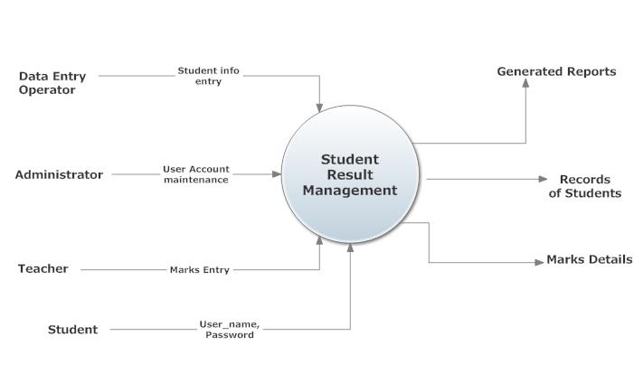

User Case Diagram

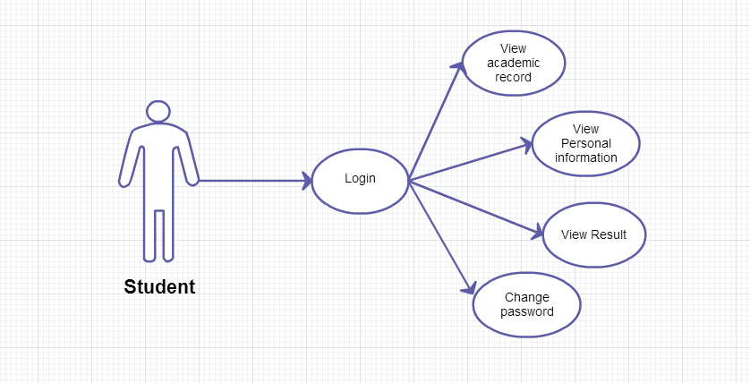

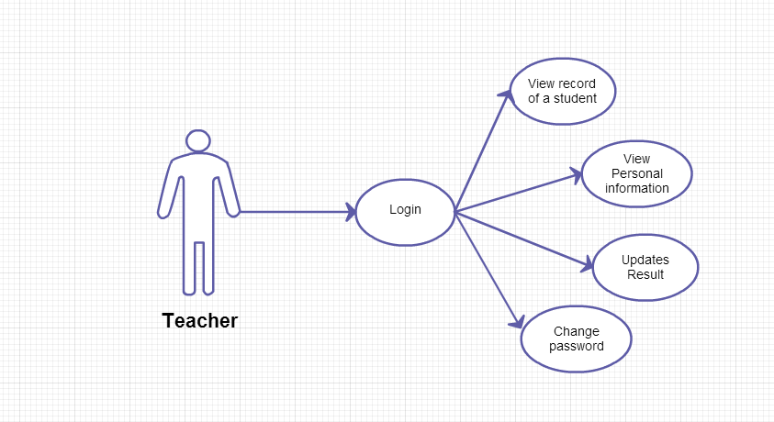

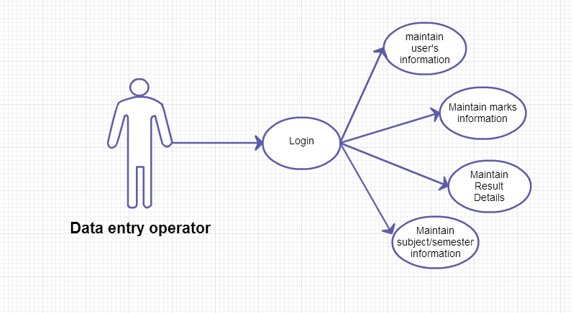

# Approval and Authority to Proceed

We approve the project as described above, and authorize the team to proceed.

|  |  |  |  |
| --- | --- | --- | --- |
| **Name** | **Title** | **Registration Number** | **Date** |
| Brian Wambui | Mr. | SCII/00813/2019 | 10/17/22 |
| Gordon Josephat | Mr. | SCII/00845/2019 | 10/17/22 |
| Boniface Kiplangat | Mr. | SCII/01358/2018 | 10/17/22 |
| Stephen Ogaro | Mr. | SCII/01353/2018 | 10/17/22 |